Sunday | Monday | Tuesday | Wednesday | Thursday | Friday | Saturday
 |  |  |  |  |  | 1
2 | 3 | 4  Mardi Gras | 5 | 6 | 7 | 8
9  Daylight Saving Time Begins | 10 | 11 | 12 | 13  Purim Begins | 14 | 15
16 | 17  St. Patrick’s Day | 18 | 19 | 20  Spring Begins | 21 | 22
23 | 24 | 25 | 26 | 27 | 28 | 29
30 | 31

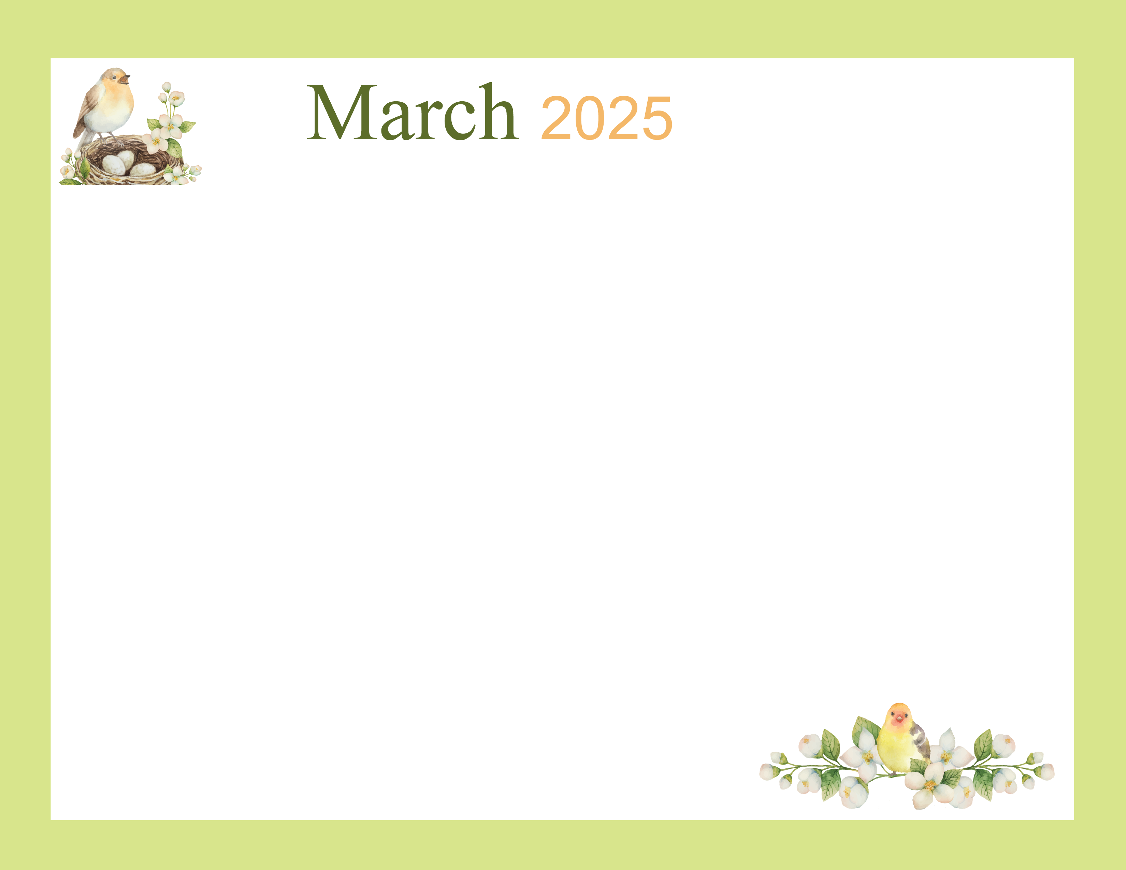 |  |  |  |  |  | Welcome to March  10:30 Coffee Social &  March IQ  11:30 News Up-Date  2:00 Noodle Ball  3:00 Word Search
Red Carpet Day  Eucharistic Minister  1X1 Visits  Friendly Visits  Find-a-Word  2:00 Grace Baptist | 3rd Day 3rd Month  10:15 Tranquil Stimulation Program  10:00 Daily Chronicle  10:15 3 letter Words / Resident Meeting  2:00 BingoCize  6:30 Evening Activity | Pancake Tuesday  10:15 Tranquil Stimulation Program  10:00 Daily Chronicle  10:15 Culinary Arts Pancakes  2:00 Bingo  3:00 Word Search | Ash Wednesday  10:15 Tranquil Stimulation Program  10:00 Daily Chronicle  10:15 Food Committee  2:00 Hymn Sing & God`s Word  6:30 Evening Activity | National Frozen Food  10:15 Tranquil Stimulation Program  10:00 Daily Chronicle  10:15 Frozen Food Mining  2:00 Bingo  3:00 Word Search | Lucky Seven  10:15 Tranquil Stimulation Program  10:00 Daily Chronicle  10:15 Roll the Dice (7)  2:00 Bowling Tournament  3:00 Word Search | Choose Your Words Well  10:30 Coffee Social & Choose your words Wisely  11:30 News Up-Date  2:00 Noodle Ball
Daylight Savings  Eucharistic Minister  1X1 Visits  Friendly Visits  Find-a-Word  2:00 Grace Baptist | Clover All Over  10:15 Tranquil Stimulation Program  10:00 Daily Chronicle  10:15 Activity Meeting  2:00 BingoCize w/ Clovers  6:30 Evening Activity | Tech Tuesday  10:15 Tranquil Stimulation Program  10:00 Daily Chronicle  10:15 March Trivia  11:30 News Up-Date  2:00 Bingo / bingo caller  3:00 Word Search | Chinese Culture  10:15 Tranquil Stimulation Program  10:00 Daily Chronicle  10:15 Video History of China & Art Craft  2:00 God`s Word  6:30 Evening Activity | Purim Begins  10:15 Tranquil Stimulation Program  10:00 Daily Chronicle  10:15 Story of Purim & Purim Word Games  2:00 Bingo  3:00 Word Search | Billy Crystal B-Day  10:15 Tranquil Stimulation Program  10:00 Daily Chronicle  10:15 Facts, Trivia & Billy Crystal Word Game  2:00 Monthly Birthday Party | Doobie Brothers  10:30 Coffee Social & Doobie brothers` music  11:30 News Up-Date  2:00 Greater Works / Children
Folktales  Eucharistic Minister  1X1 Visits  Friendly Visits  Find-a-Word  2:00 Grace Baptist | St. Patrick`s Day  10:15 Tranquil Stimulation Program  10:00 Daily Chronicle  10:15 Thing that are Green w/ Corporate Kids  2:00 St Patty`s Party  6:30 Evening Activity | March Madness  10:15 Tranquil Stimulation Program  10:00 Daily Chronicle  10:15 Basketball Trivia  11:30 News Up-Date  2:00 Hoops Bingo  3:00 Word Search | Wyatt Earp  10:15 Tranquil Stimulation Program  10:00 Daily Chronicle  10:15 Shoot Out  11:30 News Up-Date  2:00 God`s Word  6:30 Evening Activity | Spring Equinox  10:15 Tranquil Stimulation Program  10:00 Daily Chronicle  10:15 Springtime Secret Message  2:00 Bingo  3:00 Word Search | Aries / Horoscopes  10:15 Tranquil Stimulation Program  10:00 Daily Chronicle  10:15 Aries / Horoscopes  2:00 Happy Hour  3:00 Word Search | Goof-Off Day  10:30 Coffee Social & Ways to goof-off  11:30 News Up-Date  2:00 Noodle Ball  3:00 Word Search
Dixie Cup  Eucharistic Minister  1X1 Visits  Friendly Visits  Find-a-Word  2:00 Grace Baptist | Peyton Manning  10:15 Tranquil Stimulation Program  10:00 Daily Chronicle  10:15 Peyton Manning Story / football trivia  2:00 BingoCize  6:30 Evening Activity | Waffle Day  10:15 Tranquil Stimulation Program  10:00 Daily Chronicle  10:15 Waffles &Coffee  11:30 News Up-Date  2:00 Bingo  3:00 Word Search | World Math Day  10:15 Tranquil Stimulation Program  10:00 Daily Chronicle  10:15 Solving Math Problems & Shopping  2:00 God`s Word  6:30 Evening Activity | Outdoor Sports  10:15 Tranquil Stimulation Program  10:00 Daily Chronicle  10:15 Outdoor Games  11:30 News Up-Date  2:00 Bingo  3:00 Word Search | Reba McEntire  10:15 Tranquil Stimulation Program  10:00 Daily Chronicle  10:15 Playing Cards w/ Reba Music  2:00 Ice Cream Social  3:00 Word Search | Mom & Pop Business  10:30 Coffee Social &  Discussion Mom & Pop Business Owners  2:00 Noodle Ball  3:00 Word Search
Doctor`s Day  Eucharistic Minister  1X1 Visits  Friendly Visits  Find-a-Word  2:00 Grace Baptist | Starbucks  10:15 Tranquil Stimulation Program  10:00 Daily Chronicle  10:15 Coffee Social  2:00 BingoCize  6:30 Evening Activity | Bay Terrace
Activities are subject to change.

